LAB 4

RADIO FREQUENCY AND MICROWAVE CIRCUIT DESIGN
MICROWAVE BANDPASS FILTER

- Introduction

A bandpass filter is an electronic device or circuit that allows signals between two specific frequencies to pass, but that discriminates against signals at other frequencies. Some bandpass filters require an external source of power and employ active components such as transistors and integrated circuits; these are known as active bandpass filters. Other bandpass filters use no external source of power and consist only of passive components such as capacitors and inductors; these are called passive bandpass filters.

The illustration shown in Figure 1 is an amplitude-vs-frequency graph, also called a spectral plot, of the characteristic curve of a hypothetical bandpass filter. The cutoff frequencies, f₁ and f₂, are the frequencies at which the output signal power falls to half of its level at f₀, the center frequency of the filter. The value f₂ - f₁, expressed in hertz (Hz), kilohertz (kHz), megahertz (MHz), or gigahertz (GHz), is called the filter bandwidth. The range of frequencies between f₁ and f₂ is called the filter passband.

Amplitude, dB

0dB
-3dB

f₁ f_{o} f₂ Frequency

Bandwidth

Figure 1:Bandpass Filter

Bandpass filters are used primarily in wireless transmitters and receivers. The main function of such a filter in a transmitter is to limit the bandwidth of the output signal to the minimum necessary to convey data at the desired speed and in the desired form. In a receiver, a bandpass filter allows signals within a selected range of frequencies to be heard or decoded, while preventing signals at unwanted frequencies from getting through. A bandpass filter also optimizes the signal-to-noise ratio (sensitivity) of a receiver.
In both transmitting and receiving applications, well-designed bandpass filters, having the optimum bandwidth for the mode and speed of communication being used, maximize the number of signals that can be transferred in a system, while minimizing the interference or competition among signals.
Banpass filter circuits uses passive components such as capacitors and inductors for frequencies below 1 GHz. Where else for frequencies above 1 GHz especially for microwave circuits, microstrip circuits are used for design.

- Bandpass Filter Circuit Design

Bandpass filters are used as frequency selective devices in many RF and microwave applications. Filters are realized using lumped or distributed circuit elements. However with the advent of advanced materials and new fabrication techniques, microstrip filters have become very attractive for microwave applications because of their small size, low cost and good performance. There are various topologies to implement microstrip bandpass filters such as end-coupled, parallel coupled, hairpin, interdigital and combline filters.

2.1 Theory

General layout of a parallel coupled microstrip bandpass filter is shown in Figure 2. The filter structure consists of open circuited coupled microstrip lines. These coupled lines are quarter wavelength long and are equivalent to shunt resonant circuits. The coupling gaps correspond to the admittance inverters in the lowpass prototype circuit. Even and oddmode characteristic impedances of parallel-coupled half-wave resonators are computed using admittance inverters. These even and odd mode impedances are then used to compute physical dimensions of the filter.

J01 J12 J23

λ/4 λ/4 λ/4 λ/4 λ/4 λ/4

Input λ/2 Resonator

λ/2 Resonator

Output

Figure 2: Parallel Coupled Bandpass Filter

Microstrip Bandpass Filter is design by mapping the desired low pass filter frequency to the desired bandpass filter frequency. The resonator values are calculated by:

$J_{\text{01}}:={\left(\frac{π\text{.}Ω}{2\text{.}k_{0}\text{.}k_{1}}\right)}^{\frac{1}{2}}$ (1)

$J_{k\text{.}k+1}:=\left(\frac{π\text{.}Ω}{2}\right)\text{.}\frac{1}{\sqrt{k_{k}\text{.}k_{k−1}}}$ (2)

k = 1, …, n-1

$J_{n\text{.}n+1}:={\left(\frac{π\text{.}Ω}{2\text{.}k_{n}\text{.}k_{n+1}}\right)}^{\frac{1}{2}}$ (3)

k_{k} is the prototype element for low pass filter that has n section and
$Ω$ is the bandwidth of the filter.

- Design Procedure

- By using the elements of lowpass filter prototype shown in Table 1, obtain the resonator values required for the bandpass filter.

Table 1: Lowpass filter prototype elements

n | 2
k₀ | 1.0
k₁ | 1.414
k₂ | 1.414
k₃ | 1.0
$$Ω$$ | 0.159
f_{o} | 2.0 GHz

- From the calculation, obtain the data that is required for Figure 3 whereby the:

- Width of the 50$Ω$ transmission line = 2.84mm
- PCB thickness = 1.5mm
- Dielectric constant, εr = 4.5

J₂₃
J₁₂ 50 Ω

J₀₁

50 Ω λ/2

Figure 3: Bandpass Filter

- By using the data obtain from steps (a) and (b), draw the bandpass filter circuit and simulated the S-parameter circuit to obtain the S₂₁ value.

- Optimize the length of the resonator, simulate the microstrip circuit again and obtain the S₂₁ value. Compare the value with step (c). Explain on the difference in value.

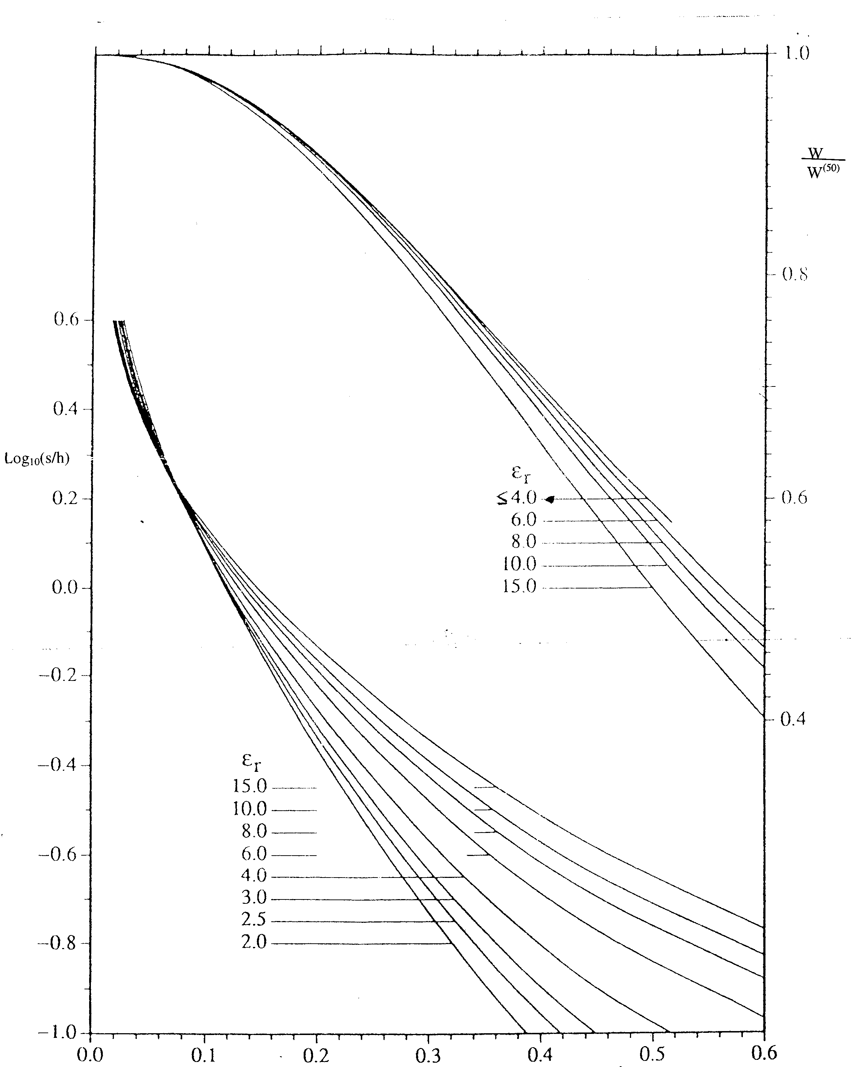
Normalised admittance inverter value, J’

